ANNEXURES
ANNEXURE 1: PLAGIARISM REPORT
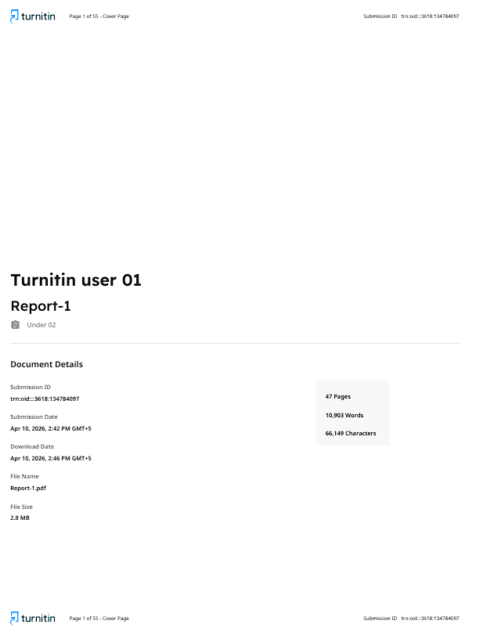

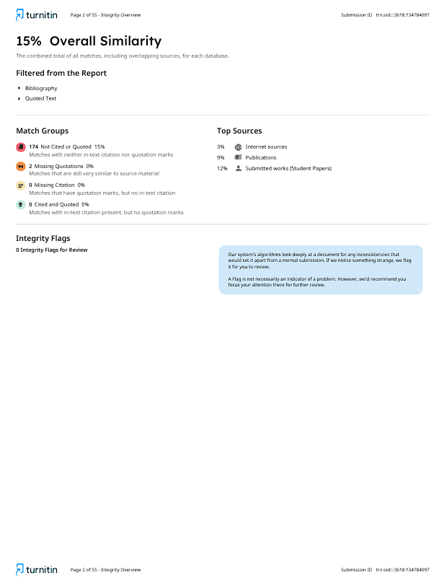

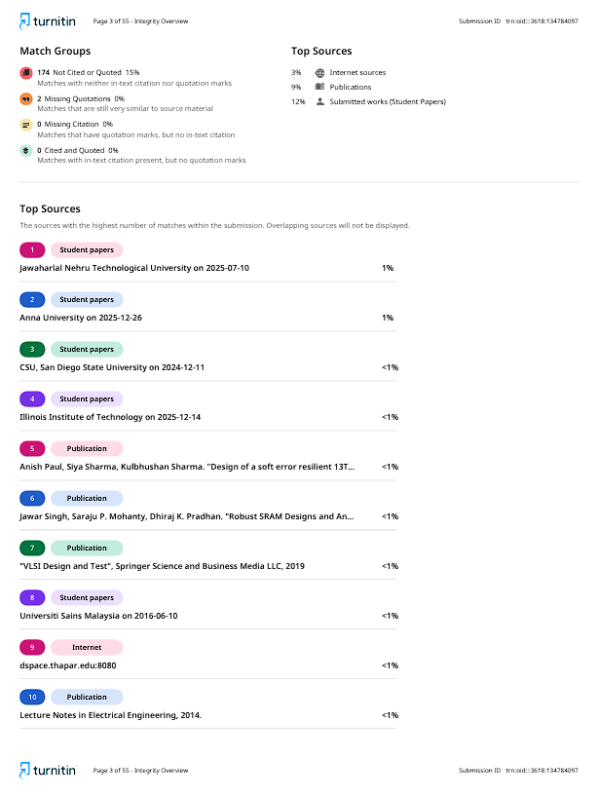

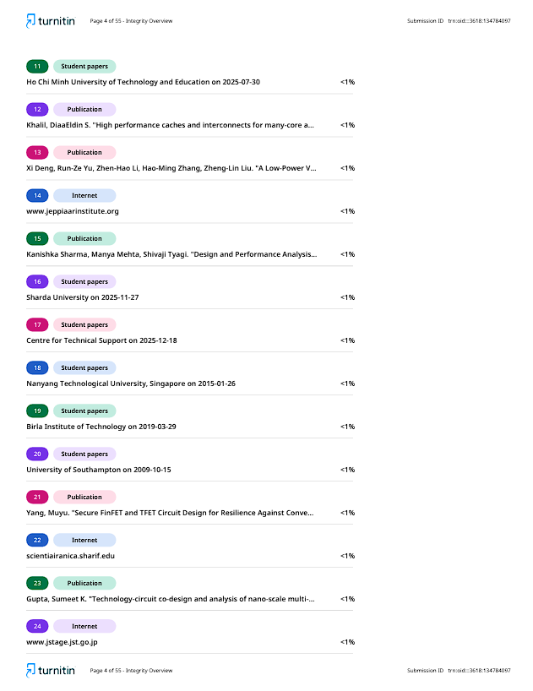



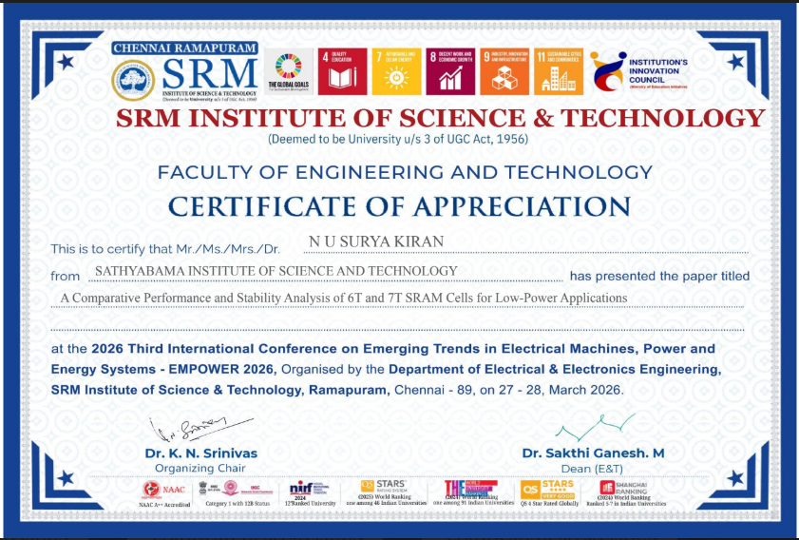
ANNEXURE 2: CONFERENCE DETAILS PROCEEDINGS WITH CERTIFICATE PUBLISHED AS THE OUTCOME OF THE PROJECT

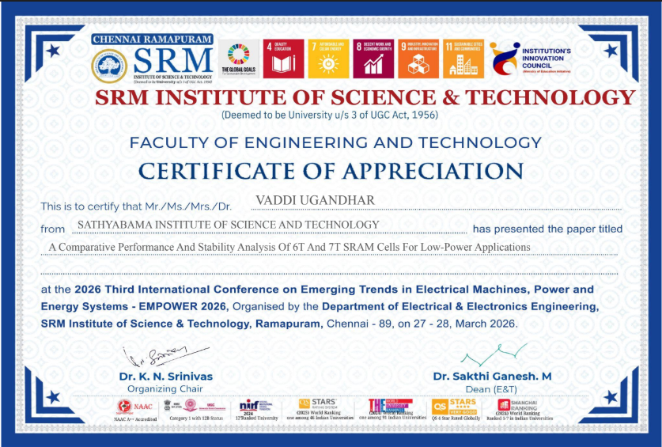

ANNEXURE 3: SDG MAPPING

SDG Mapping Table
SDG Goal No. | SDG Title | Relevance Level (Low / Moderate / High) | Justification
SDG 7 | Affordable and Clean Energy | High | The proposed SRAM design reduces power consumption through voltage scaling and optimized transistor sizing, making it suitable for energy-efficient and battery-operated systems.
SDG 9 | Industry, Innovation and Infrastructure | High | The project contributes to advanced VLSI design by improving SRAM stability and performance without increasing transistor count, supporting innovation in semiconductor memory technologies.
SDG 3 | Good Health and Well-Being | Moderate | Energy-efficient and reliable SRAM can be used in biomedical devices and wearable systems, enabling continuous and stable health monitoring applications.
SDG 4 | Quality Education | Moderate | The project enhances knowledge in VLSI design, circuit optimization, and simulation tools, contributing to technical education and research development.
SDG 11 | Sustainable Cities and Communities | Low | The low-power SRAM design supports embedded and IoT-based smart systems used in smart city infrastructure.
SDG 12 | Responsible Consumption and Production | Low | The design promotes efficient resource utilization by minimizing leakage power and avoiding additional hardware overhead.

ANNEXURE 4: PO PSO MAPPING

PO–PSO Articulation Matrix for the Project
Mapping Level: 1 – Low | 2 – Medium | 3 – High

Program Outcomes (POs) / Program Specific Outcomes (PSOs) | Mapping Level | Justification
PO1 – Engineering Knowledge | 3 | Applied CMOS fundamentals, SRAM cell design, transistor sizing (CR, PR), and noise margin concepts to develop an optimized 6T SRAM cell.
PO2 – Problem Analysis | 3 | Analyzed low-voltage SRAM challenges such as reduced SNM, leakage, and process variations through literature review and circuit-level understanding.
PO3 – Design/Development of Solutions | 3 | Designed a variation-tolerant low-power 6T SRAM cell using transistor sizing optimization without additional assist circuits.
PO4 – Investigation of Problems | 3 | Conducted simulation-based analysis (SNM, delay, power, leakage) under varying supply voltages and operating conditions to validate the SRAM performance.
PO5 – Engineering Tool Usage | 3 | Used Cadence Virtuoso and Spectre tools for schematic design, simulation, and performance evaluation of SRAM cell.
PO6 – Engineer and Society | 2 | Developed energy-efficient memory suitable for IoT and embedded systems, contributing to low-power electronics and sustainable technology.
PO7 – Ethics | 1 | Followed ethical research practices, proper citation of literature, and accurate reporting of simulation results.
PO8 – Individual and Team Work | 2 | Executed the project with guidance, collaboration, and structured task distribution during design and analysis.
PO9 – Communication | 2 | Prepared detailed technical report, documentation, and explanation of SRAM design, simulations, and results.
PO10 – Project Management | 2 | Managed design flow including literature review, simulation iterations, result validation, and report preparation within project timeline.
PO11 – Life-long Learning | 2 | Gained knowledge in advanced SRAM design, low-voltage operation, and variation-aware circuit techniques beyond academic curriculum.
PO12 – Life-long Learning | 2 | Acquired knowledge in advanced SRAM design, low-voltage operation, and variation-aware circuit techniques beyond the standard curriculum using Cadence tools and research literature.
PSO1 – Electronic Design & IC Systems | 3 | Designed and analyzed transistor-level SRAM cell, focusing on VLSI circuit design, stability, and performance optimization.
PSO2 – Signal and Image Processing | 1 | Minimal relevance; limited to general understanding of digital systems where memory is used, no direct implementation.
PSO3 – Embedded, IoT and Wireless Systems | 2 | Proposed SRAM design is suitable for low-power embedded and IoT applications requiring energy-efficient on-chip memory.

